Note: this software is provided as-is and all exported reports should be reviewed before submitting to the TEC

1. Export your ActBlue Contributions for the desired time period in CSV format.  
   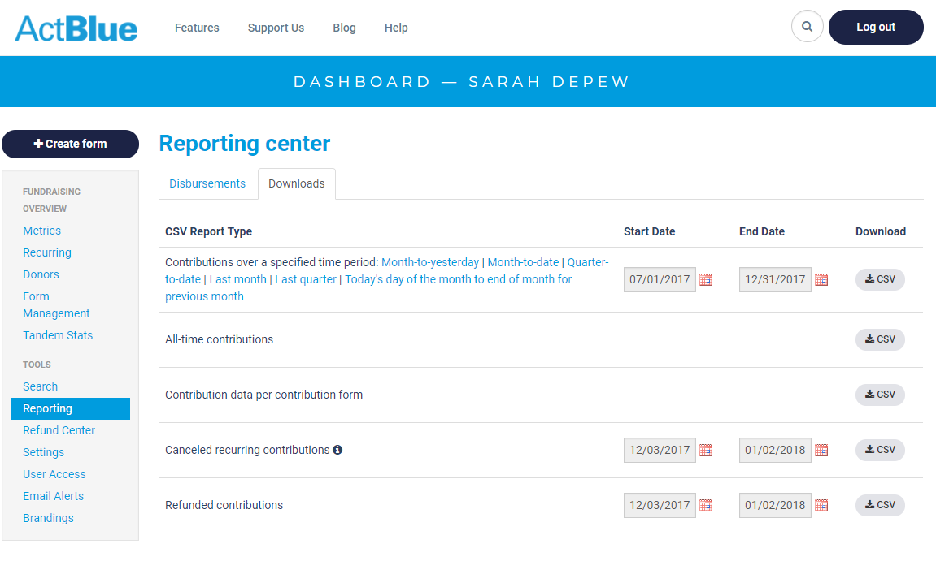
2. Run "actblue_to_tec.exe"
3. The first prompt will be for "ActBlue Export File". Navigate to and select the file you just downloaded from ActBlue.  
   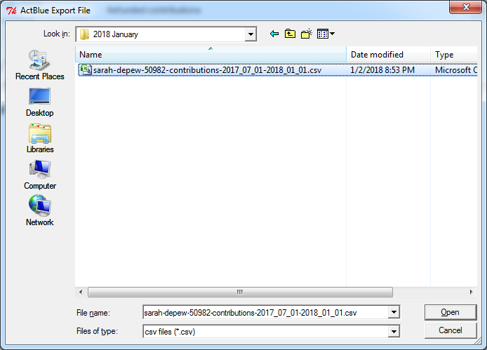
4. The next prompt will be for saving off the contribution report in the TEC CSV format.  
   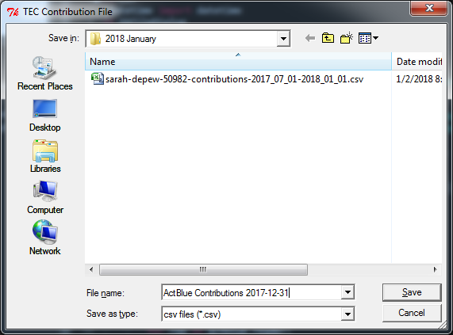
5. The next prompt will be for saving off the expense report in the TEC CSV format.

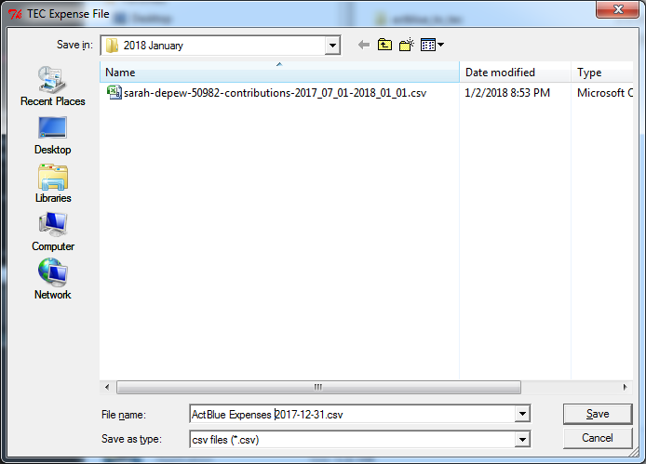

1. The exported CSV files can be imported directly into the TEC online filing system.